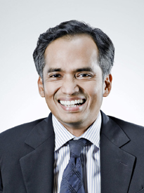

Francis Xavier S.C., PBM
Regional Head, Disputes Practices

Practice Areas:

International Arbitration
Treaty Arbitration
Commercial Litigation
Banking & Finance Disputes
Energy & Resources

Get in touch

francis.xavier@rajahtann.com
(65) 62320551

Francis is Regional Head, Disputes Practices of the firm and was appointed Senior Counsel in January 2009. He practices in the areas of international and treaty arbitration and cross-border commercial litigation. He is actively involved in corporate and commercial disputes especially in the areas of corporate, banking, property, financial and investment related claims. He also specialises in aviation law and advised in the class-action suit resulting from the crash of the SilkAir flight in Indonesia and the Taiwan SIA crash.

He is currently sitting as party-nominated arbitrator of a Mauritius entity in a bilateral investment treaty (ICSID) dispute with the Government of India. He is also counsel for an Asean government in an ICSID arbitration involving a European state investor.

Francis has been recognised as a leading lawyer by Asia Pacific Legal 500 (from 2001 to 2016), AsiaLaw Profiles (2007), Asia Law leading lawyers (2009), Chambers Global (2010 to 2016), Global Arbitration Review (2010), Chambers Asia Pacific (2011 to 2015) and the Fifth Edition of Best Lawyers in Singapore Practice area of Litigation (2013). Francis is also recognized as a leading employment lawyer by the latest edition of Chambers Asia Pacific (2014).

He is a Chartered Arbitrator and is also on the Panel of Arbitrators of the Singapore International Arbitration Centre, the Kuala Lumpur Regional Centre for International Arbitration, the Kigali International Arbitration Centre (Rwanda) and the CiArb (UK) Panel of Arbitrators. He is presently the Chairman of the Singapore CiArb.

